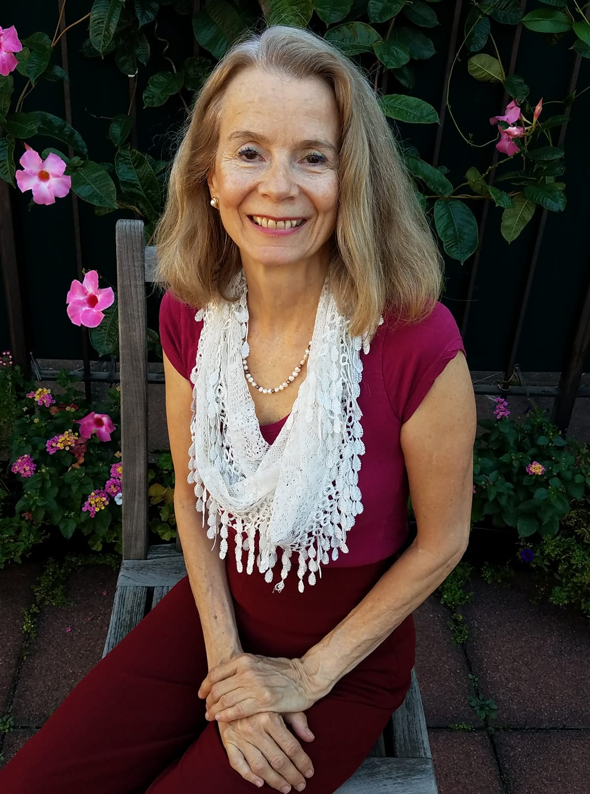

1. Trace Your Beginnings--from embryo to baby! **Sunday August 18  2019**

## 2. The Vestibular System: Listening and Balancing **Sunday September 22, 2019** 3. The Eyes: Seeing and Believing **Sunday October 20, 2019**

**4. The Nose: Smelling Mom and Dad**  
**Sunday Nov. 24, 2019**

5.The Tongue: TMJ, Nursing,Swallowing **Sunday, Dec. 15, 2019**

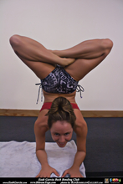

Personal Study--Living Anatomy Classes  
  
With actual models of the bones, we will discover our own vertebra--feeling them, noticing their changing structures and their functions. We will learn about the bones with the Body-Mind Centering® perspective as a living tissue with it's own mind and clarity.  
  
Each of the vertebrae has a unique feature and shape. If you close your eyes and imagine drawing the neck, thoracic or lumbar vertebrae, you might be amazed by the curves, struts, and holes that provide us with protection, support, and housing for the spinal cord. Feel what this means in your body after examining and learning about these bones. How the spine develops embryologically gives us exciting pathways to explore in movement, which makes learning come alive!  **Time TBD For each student**.

#### **5 Sunday Seminars monthly**

#### **from 11am to 4pm**

#### **$400 for all ($100 each)**

#### **go to PayPal or Venmo**

#### **646.408.6419**

**Learn about the motor development of your body and how hearing, balancing, seeing and tasting lead you into your environment where you explore life. These explorations help you develop into the person you are today, and can be re-experienced and re-patterned to enrich and inform you current self-expression. Each month we'll explore a different perception and discover its effect on our move-ment and consciousness.**

# Aliquam

Sara K. Vogeler, Director The NeuroMuscular Center 212.242.4962

148 W. 23 Street, NY NY 10011

14

🙞 🙜

*Trace*

*your* *Beginnings!*

*Summer/Fall 2019*

*classes*

**Body-Mind Centering ®**, developed by Bonnie Bainbridge Cohen, O.T., is a truly unique approach to exploring one's body and consciousness in the spirit of self-discovery.  BMC® opens up personal development in the context of dance, anatomy, physiology, and embryology. It offers a means to experience the body in movement from embryo to adulthood as a way to free the mind, and change habitual ways of moving.

For example, you may discover how you were formed as an embryo --from folding to dividing to organizing into a complex living organism. That experience may show you why you stand and move  and even think the way that you do.

Tracing your beginnings may bridge the gaps that undoub-tedly formed due to inefficien-cies in utero and in infancy that may be holding you back physically, emotionally, mentally or spiritually. You can fill in these missed parts of your development in a profound re-integration of self by taking these classes.

**Sara K. Vogeler**, Founder and Director of The Neuro-Muscular Center, Inc., started training with Bonnie in 1973 as a student in Dance Therapy at NYU. After graduating, she became a professional dancer and choreographer, and appren-ticed with the Erick Hawkins Dance Company, then per-formed with Beverly Brown, David Woodberry, Pauline DeGroat, and others. As a certified BMC teacher, she taught in colleges and centers in Amsterdam, Paris, Munich, and New York. She studied pre-med, and was certified in Myofunctional Therapy for TMJ, in Personal Training by ACE, as an Orthopedic Exercise Specialist, and as a Massage Therapist licensed by New York State. She has been in practice over 45 years helping people with pain or developmental delays due to disease, chronic conditions or sports injuries. She cofounded the Body-Mind Centering Association, serving as president there and later at the International Somatic Movement Education and Therapy Association(ISMETA).